**Online Food Order**

**Software Design Assignment**

**BE in Software Engineering**

**(4th year) Level-8**

**Submitted By:-Vivek Modi**

**Student Id- A00268807**

**Athlone Institute Of Technology**

**Ireland**

November 13, 2019

**Title of the Assignment:-** Online Food Order

**About the system:-**

The main aim of this project is to deliver food from restaurant through this application. The customer will login or signup as per requirements then the user can select the item as per choice. This system is developed in java, using inheritance, customization of GUI, jtables, database, array-list, swing GUI and some more. Food order system is helpful as user can order food online without going to the restaurant. Each item in the menu has a different price as we have in the restaurant menu. After choosing the preferences from the menu a bill is generated which is specific regarding the rate, quantity and total cost. This is a secure system as user has to either login or signup and system uses database to store data in it.

**Classes:-**

Custom:

* RoundedButton.java

Data:

* CheckInsertData.java
* RefinedData.java

Database:

* Dbconnector.java
* InsertData.java

Interface:

* DataBaseInterface.java

MainClass:

* BillScreen.java
* Food_Order.java
* LoginScreen.java
* MainScreen.java
* SignUpScreen.java

Utils:

* CheckBoxHelper.java
* DataHelper.java
* LoginData.java
* PriceHelper.java

**Functionalities Used:-**

* Java
* Interface
* Single Inheritance
* Array-list
* Database
* Customized Button, Frames.
* Jtables

**Key Parts of Code :-**

* Use of database to store signup and login details

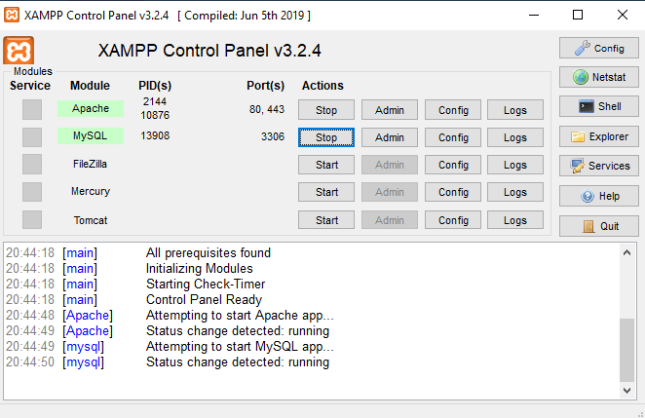

(xampp server)

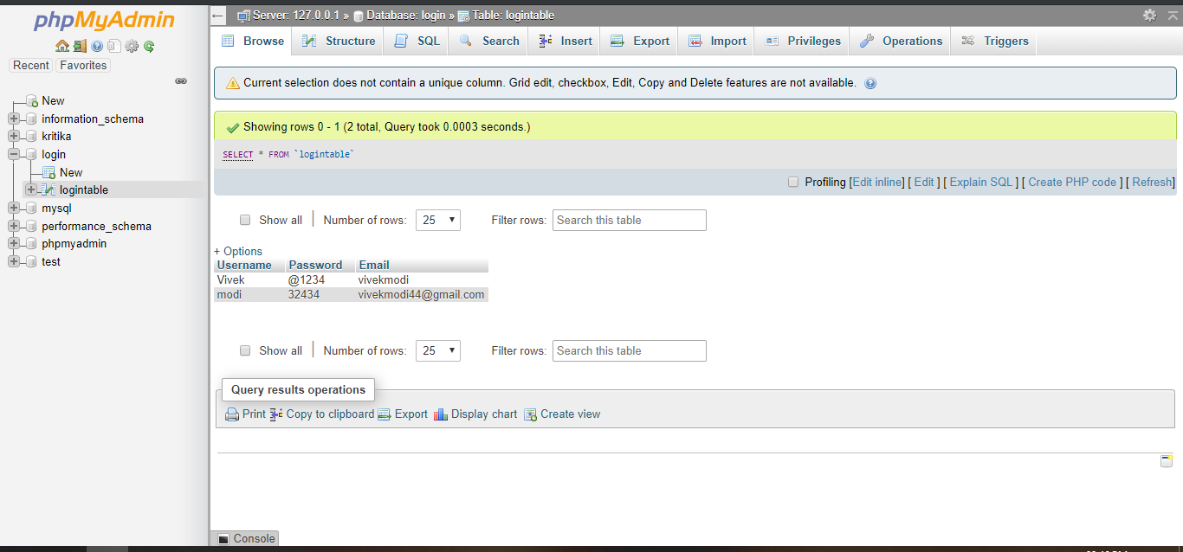

(login and signup data is stored in database)

* Connecting with the database

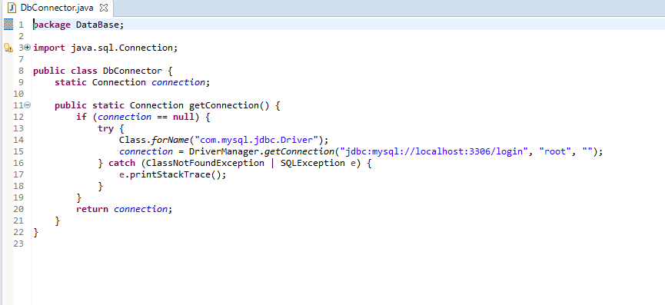

The use of Class.forName()to load a JDBC driver. The JDBC driver should namely register itself in DriverManager inside the block.

* Use of Single Inheritance

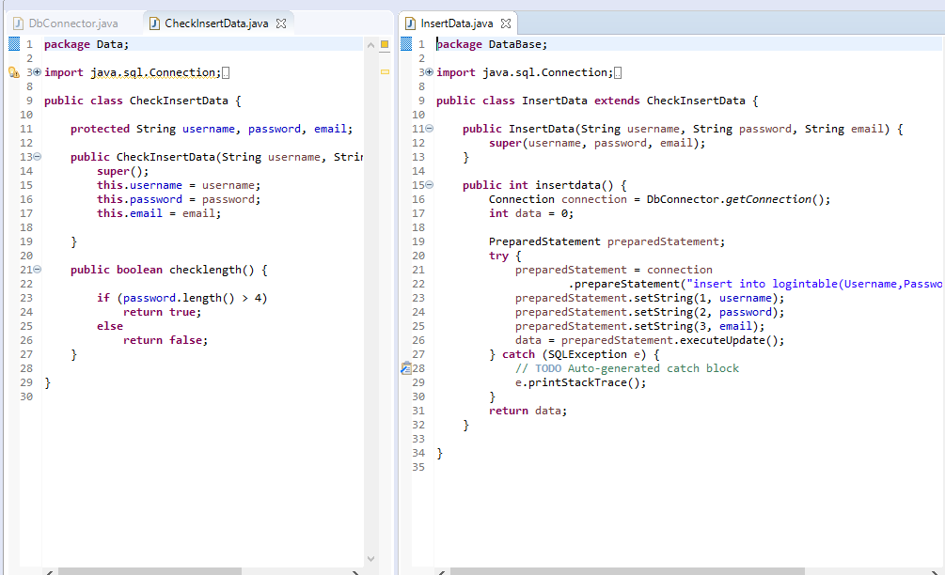

Inheritance in java is a mechanism in which one object acquires all the properties and behaviors of a parent object. It is an important part of Object Oriented programming.In case of PreparedStatement, Database use an already compiled and defined access plan, this allows prepared statement query to run faster than normal query.

* Use of Interface

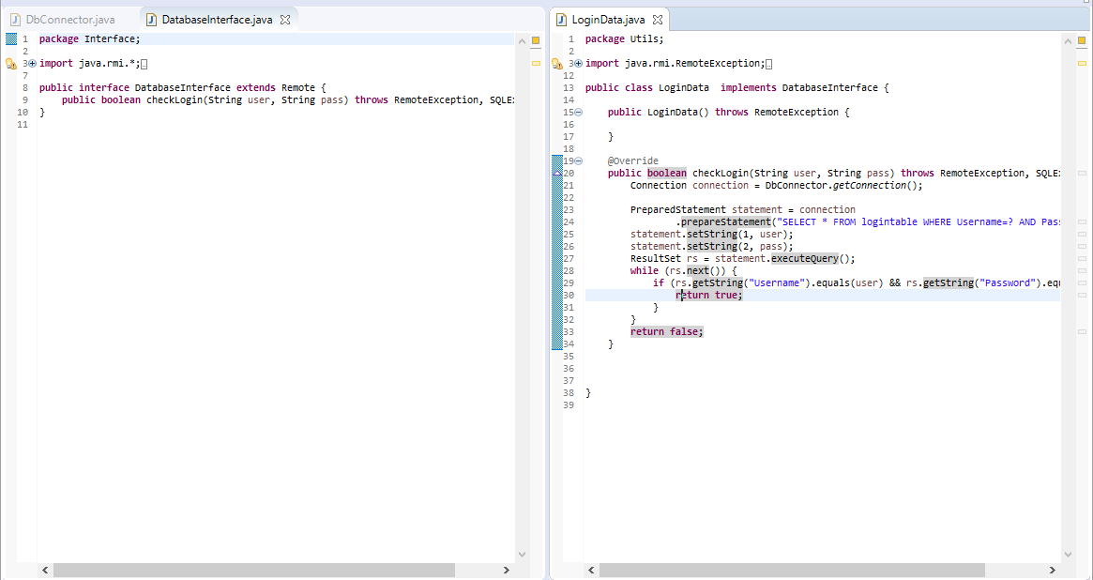

To access the interface methods, the interface must be "implemented" (like inherited) by another class with the implements keyword. The body of the interface method is provided by the "implement" class.

* Use of array list

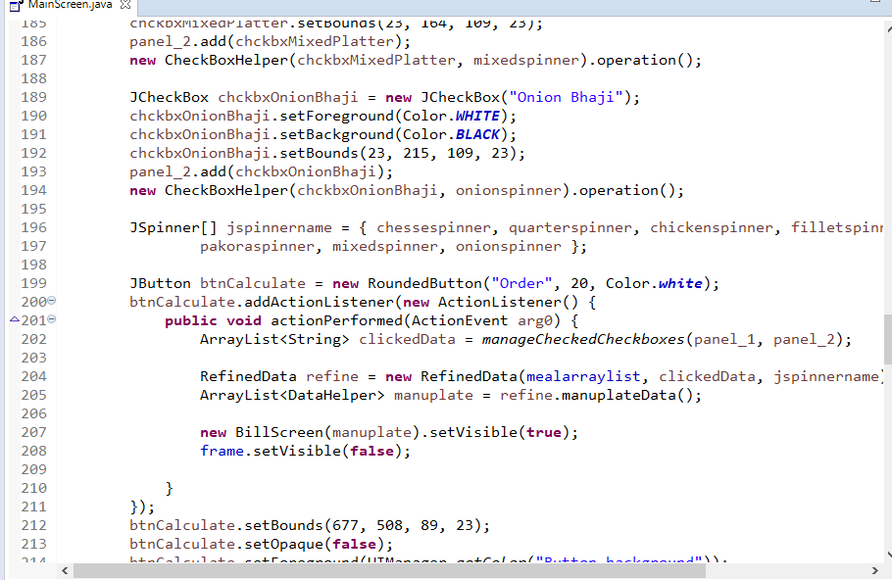

The arraylist class is a resizable array, which can be found in the java.util package.

* Customized Button

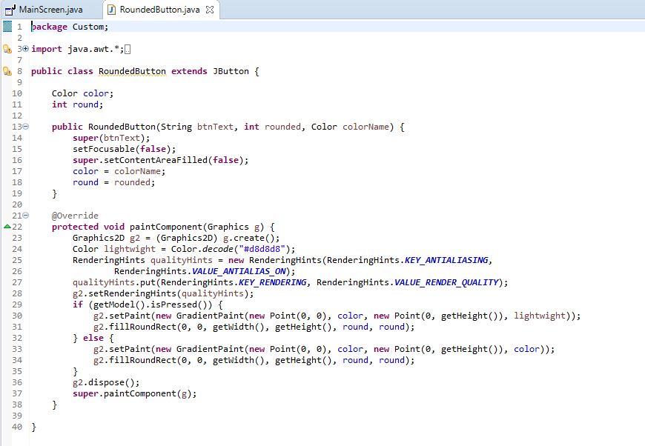

* Checkbox Helper

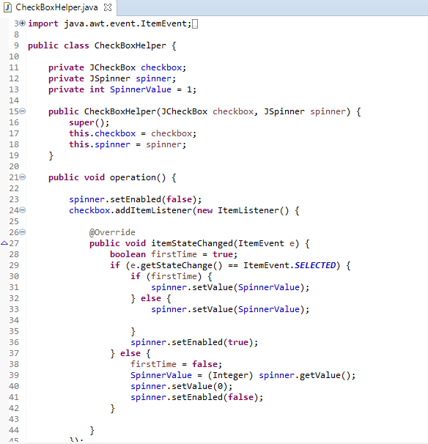

* Class Array List

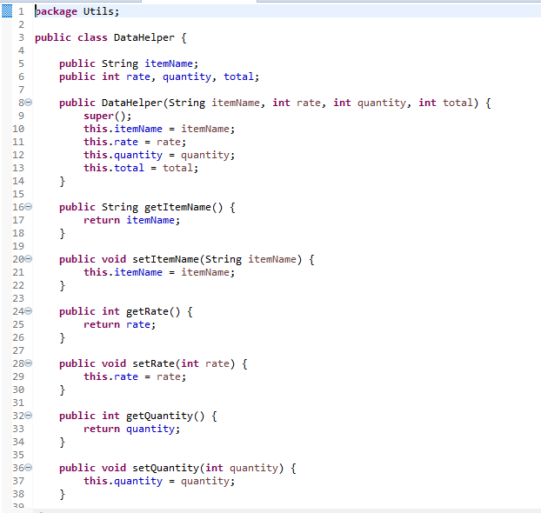

**Screenshots:-**

* **Welcome Screen**

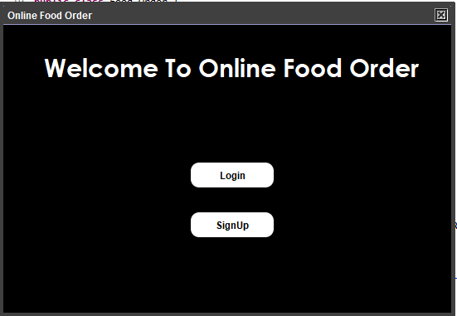

* **Login Screen**

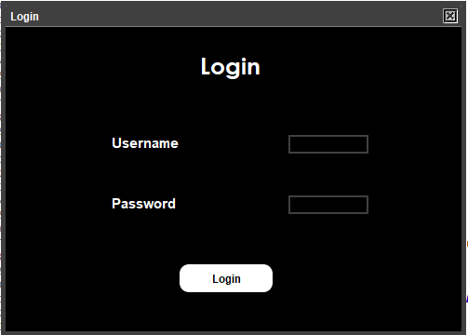

* **SignUp Screen**

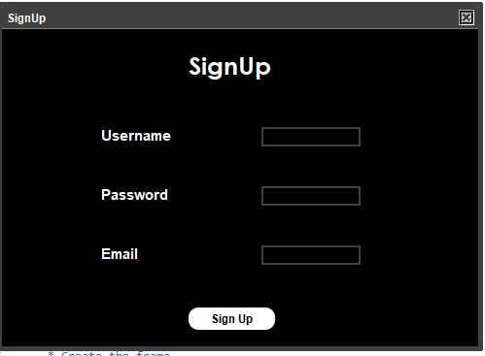

* Main Screen

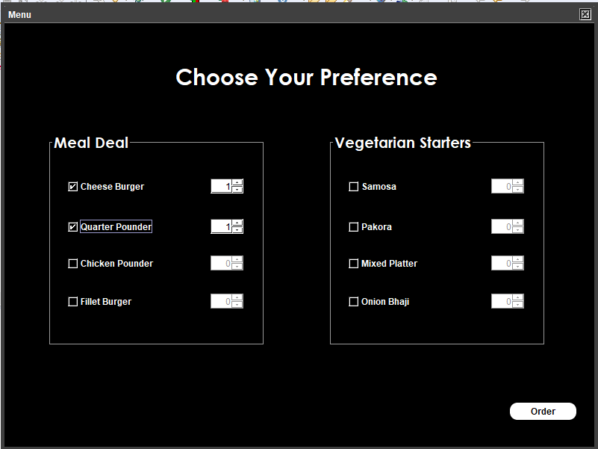

* **Bill Screen**

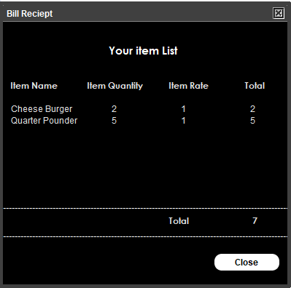

* Confirmation Screen

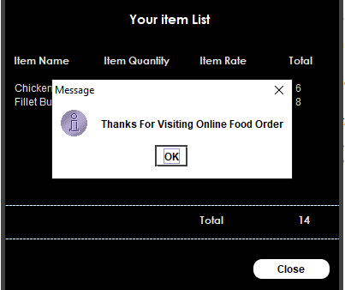

**Problems encountered During Development :-**

* Designing a custom GUI

To design my GUI I had to customize the buttons and frames. I was facing problems while doing that, so I studied and learned customizing the GUI through Oracle website and Stack overflow. At the Oracle website I read a documentation regarding objects, constructor and methods for customization. Whereas stack overflow helped me with the syntax.

**Conclusion:-**

This system has been computed successfully. It is user friendly and consist of various options for the user. This system is a safe as well as a time saver for the user as he can choose among the preferences without going to a restaurant. I did faced some issues while making this system, but I resolved them after studying and learning about them on the internet. This system helped me in learning and clearing other concepts in java.